Python Programming (R1UC427B)
Adarsh Srivastava (24SCSE1010698) Section – 3 Lab P1
Practical 1: Python Data Types & Variable
1.1 WAP to print "Hello, World"
Code : print ("Hello, World")
Output :
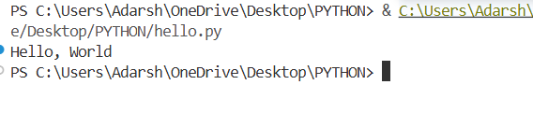
1.2 WAP to declare and print different types of variables
Code :
a = 25
b = 6.7
c = 45.89
d = 'Z'
e = True
f = "Adarsh"
print("Integer:", a)
print("Float:", b)
print("Double:", c)
print("Character:", d)
print("Boolean:", e)
print("String:", f)
Output :
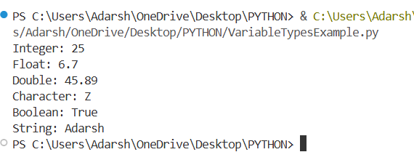
1.3 WAP to take user input and display its data type
Code :
x = input("Enter something: ")
print("You entered:", x)
print("Data type:", type(x))

Output :

1.4 WAP to swap two variables
Code :
a = 10
b = 20
a, b = b, a
print("a =", a)
print("b =", b)

Output :
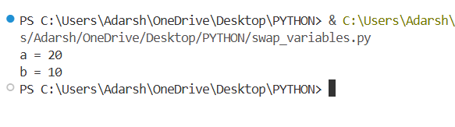
1.5 WAP to assign multiple variables in a single line.
Code :
a, b, c = 10, 20, 30
print("a =", a)
print("b =", b)
print("c =", c)
Output :
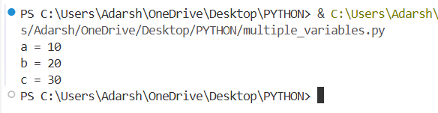
- Exercise
E1: Write a Python program to find the sum and average of two numbers.
Code :
num1 = float(input("Enter first number: "))
num2 = float(input("Enter second number: "))
sum_result = num1 + num2
average = sum_result / 2
print("Sum =", sum_result)
print("Average =", average)
Output :
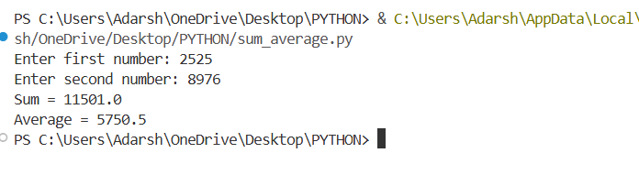
E2: Write a program to check whether a given number is positive, negative, or zero.
Code :
num = float(input("Enter a number: "))
if num > 0:
print("The number is Positive")
elif num < 0:
print("The number is Negative")
else:
print("The number is Zero")
Output :
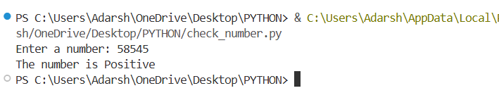
E3 : Write a program to swap two numbers using a temporary variable.
Code :
num1 = int(input("Enter first number: "))
num2 = int(input("Enter second number: "))
print("Before swapping:")
print("num1 =", num1)
print("num2 =", num2)

temp = num1
num1 = num2
num2 = temp
print("After swapping:")
print("num1 =", num1)
print("num2 =", num2)
Output :
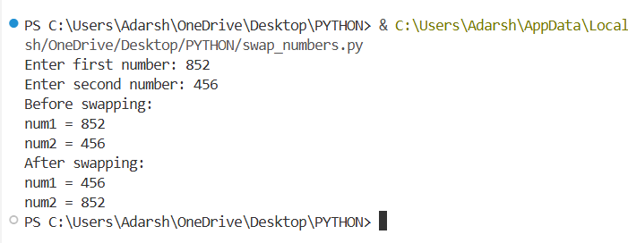
Practical 2: Operators in Python

2.1 WAP using arithmetic operators
Code :
a = int(input("Enter first number: "))
b = int(input("Enter second number: "))
print("Addition:", a + b)
print("Subtraction:", a - b)
print("Multiplication:", a * b)
print("Division:", a / b)
print("Modulus:", a % b)
print("Floor Division:", a // b)
print("Exponent:", a ** b)
Output :
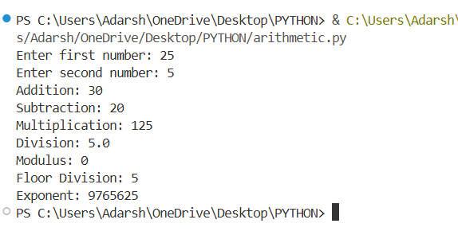
2.2 WAP using relational operators
Code :
a = 10
b = 20
print("Value of a =", a)
print("Value of b =", b)
print("a == b :", a == b) # Equal to
print("a != b :", a != b) # Not equal to
print("a > b :", a > b) # Greater than
print("a < b :", a < b) # Less than
print("a >= b :", a >= b) # Greater than or equal to
print("a <= b :", a <= b) # Less than or equal to
Output :
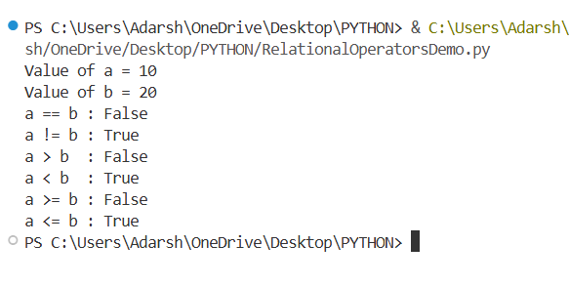
2.3 WAP using logical operators
Code :
a = 10
b = 20
c = 5
print((a < b) and (b > c))
print((a > b) or (b > c))
print(not(a < b))
Output :
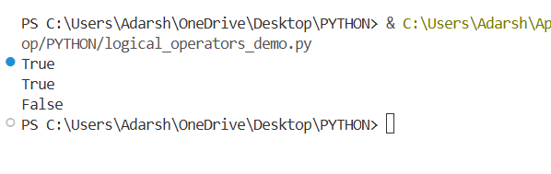
2.4 WAP using assignment operators
Code :
a = 10
b = 5
print("Initial values:")
print("a =", a)
print("b =", b)
a += b
print("a += b :", a)
a -= b
print("a -= b :", a)
a *= b
print("a *= b :", a)
a /= b
print("a /= b :", a)
a %= b
print("a %= b :", a)

Output :
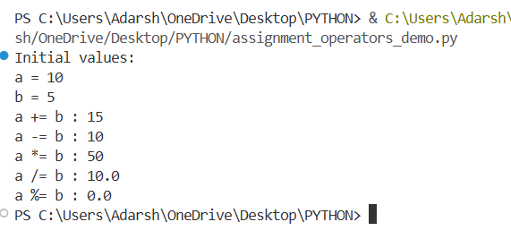
- Exercise
E1:WAP to perform all arithmetic operations using user input values.
Code :
num1 = float(input("Enter first number: "))
num2 = float(input("Enter second number: "))
addition = num1 + num2
subtraction = num1 - num2
multiplication = num1 * num2
if num2 != 0:
division = num1 / num2
else:
division = "Undefined"
print("Addition =", addition)
print("Subtraction =", subtraction)
print("Multiplication =", multiplication)
print("Division =", division)
Output :
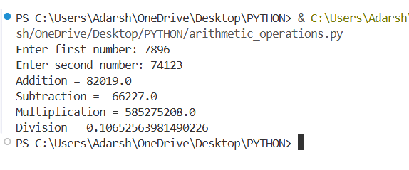
E2: WAP to check whether a number is greater than, less than, or equal to another number using relational operators.
Code :
num1 = float(input("Enter first number: "))
num2 = float(input("Enter second number: "))
if num1 > num2:
print("First number is greater than second number")
elif num1 < num2:
print("First number is less than second number")
else:
print("Both numbers are equal")
Output :
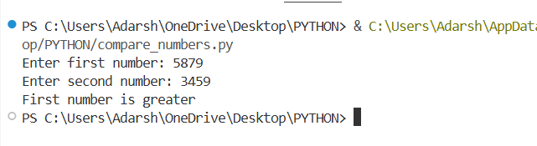
E3: WAP to demonstrate logical operators using two boolean values
Code :
a = True
b = False
print("AND:", a and b)
print("OR:", a or b)
print("NOT a:", not a)
print("NOT b:", not b)
Output :
